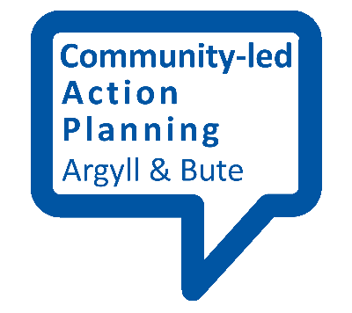
Community views questionnaire template

_________ is currently carrying out a community views survey in _________

Tell us what you think
We are a local group who want to find out what people here feel is important about their community and what improvements they would like to see. We will use the results to create a community-led action plan for ___________.

If you would like to have your say on what you feel is important to you as a resident of ________ simply fill out the survey questionnaire attached and hand it in to the community centre or the ________ shop. Alternatively, you can fill it out on line at: __________________.

So, please take the time to tell us your views about what would make ________ an even better place to live!

For more information contact _________________

Community views survey
Please answer every question if you can. If you want to, you can provide your name and contact details at the end of this survey and receive further information. All responses will be kept anonymous and confidential.

- Please tell us your age range: (circle)
Under 10 | 10-12yrs | 13-16yrs | 17-18yrs | 19-25yrs | 26-40yrs | 40-50yrs | 51-65yrs | Over 65yrs

- Please tell us your gender (circle)
Male | Female | Other

- Tell us at least three things you like about your community.

- Tell us at least three things you don’t like about your community.

- What improvements would you like to see that will make your community a better place to live?

- Do you use any of the following local facilities?
Facility | Yes | No | Have before but don’t now | Wouldn’t ever use
Community Centre
Library
Local shops
Local parks/open spaces
Computers in community centre

- Can you make any suggestions for improving the facilities or any other changes that would make you use them more?

- What would you like to see more of/participate in locally if you had the chance?

- What means of transport do you use to get around? (please tick those you use most frequently)
Car
Taxi
Public Transport
Bicycle
Foot

- Do you have any issues with transport? If so, please tell us what they are.

- Do you feel that _________ is a safe place to live? (please circle)
Yes | No

- If ‘no’ could you tell us why, and what you feel would make it safer?

- Do you feel that you have access to the services, support and activities you need to live a healthy and active life? (please circle)
Yes | No

- If ‘no’ what would you like to see in your area?

- Are there adequate opportunities for local people to get involved in education and training to improve their chances of employability?
Yes | No | Don’t Know

- If no, what would you like to see in your area that could improve people’s chances of getting a job?

- Do you have access to advice and guidance on the following:

 | Yes | No don’t need any | No but would like advice & information
Universal credit

Bedroom tax

General financial advice
Legal advice (on money matters)

- Do you feel that there are adequate opportunities for people to get involved in leisure and recreation activities locally?
Activities | Yes | No | Don’t Know
Sports
Leisure
Recreation
Arts

- If no, what would you like to see more of in your area?

- To what extent do you feel a ‘sense of belonging’ to __________? (Please circle)
Stong sense | Fairly strong | Neutral | Low sense of belonging | I don’t belong here

- What do you think would increase your sense of belonging to the area?

- Would you be interested in finding out more about opportunities for local volunteering and/or getting involved in community activities? If yes, please leave your contact details below.
Yes | No | Don’t Know | Not interested

Name:
Address:

Phone Number:
Email:

- Anything else you would like to tell us?

Thank you for taking part!!

