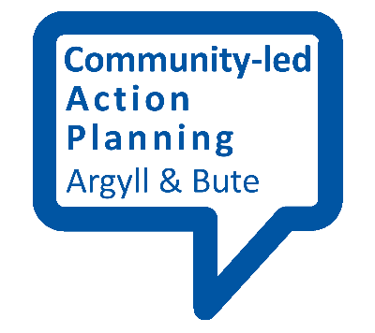
Planning Template 2

Outcome  (What do we want to achieve?) | Activities  (What will we do to achieve our outcomes?) | Actions  (Who, when and how – specific targets for action)

