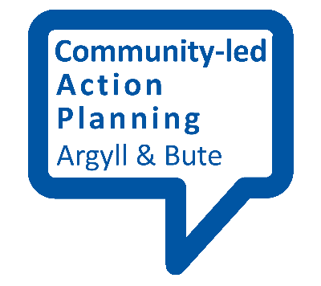
Planning Template 1

Outcome  (What do we want to achieve?) | Indicators  (How will we know we’ve been successful?) | Evidence  (How will we show that we’ve been successful)

