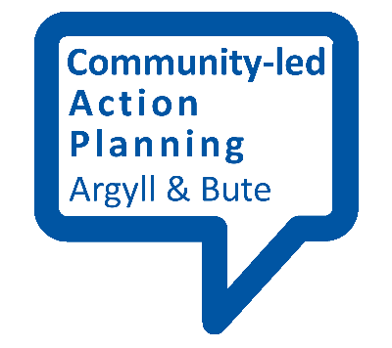
What makes a good Vision?

This fact sheet provides an outline of what makes a good vision (and what doesn’t)

Key elements of a good vision
- Inspirational – it should give people real hope for the future and inspire them to be part of making it a reality
- Ambitious – it’s good to be ambitious as there is real energy within communities that shows that people can make significant changes for the better
- Realistic – but we need to be realistic as well and know what is within our scope for influence
- Creative – there’s nothing like communities for being creative about achieving our ambitions – community-led action plans don’t need to be bound by bureaucracy and can test out fresh and interesting projects and initiatives
- Descriptive – a vision should be broad but at the same time detailed enough that everyone who reads it knows what we’re trying to achieve
- Clear – it should be clear in its language and should be jargon-free
- Ideal period of time – it should identify what the timescales are for achieving real progress

What it’s not
- A mission statement – mission statements are much more detailed descriptions of how you’re going to reach your vision
- A work plan – this is what your detailed action plan is for
- A dream – it’s much more practical than that, and should be rooted in reality as well as ambition

