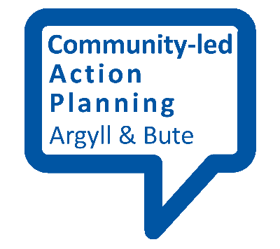
Making a questionnaire

It is unlikely that you will start a community-led action plan without finding out what the priorities of the community are. A questionnaire is a commonly-used way to do this. Here are some of the key things to think about when designing one.

Who will you ask?
You may not be able to find out the views of everyone in your community, but it is important to give as many people as possible the chance to respond, and to get the views of different groups within your community.
Sampling
It is possible to select a sample number of people (or households) to complete questionnaires or to do face-to-face interviews with. You could decide to go to every 2nd door, for instance. Alternatively, you may simply aim to cover a range of groups of people, by age, gender and minority group.
Snowballing
In this technique, you will ask people you have interviewed if they can introduce you to other people they know, who you will then interview as well. You will then continue interviewing until you find that you aren’t getting any new answers. The thinking behind snowballing is that there is a point when there is nothing more to be gained and all you are doing is carrying on for the sake of it.
If you are using this approach you should not just ask two or three people but a realistic number. For example, if you are asking questions relating to an issue concerning a street of 100 houses and the first 20 to 30 people all give you the same answers to your questions then there is not much chance that by carrying on with the research you are likely to get anything significantly different. You probably have the answers you need.

Size of Questionnaire
Try to be disciplined when devising your questionnaire. It is easy to ask too many questions in order that everything is covered. This takes up a lot of your time, takes a long time to analyse, and you may well end up with information you are unlikely to ever use. People will also be less likely to complete your questionnaire.
For every question think about why you need the information and what purpose it serves in relation to your plan. If you can’t clearly identify a reason you probably don’t need to ask it.

The Questions
Once you have decided on the focus and format of your questionnaire, you can begin to design the questions you will ask.
Leading questions
Be careful that you are not asking leading questions where the question is constructed in such a way that the person answering is encouraged to give a particular answer. Here is an example of a leading question:
‘Do you agree the community facilities here are rubbish?’
Good questions should always be phrased in a neutral, unbiased, way so that the person answering reflects their own views or feelings. For example:
‘How would you rate the community facilities here?’ (Please tick one)
Very Good / Good / Alright/ Poor / Very Poor
Closed questions
The above question is in ‘closed’ format, which tend to be quantitative in that they ask ‘how many’ questions. This means people are given options to choose from and tick or circle as appropriate. This format is good for easy analysis in terms of getting numbers and percentages quickly. The drawback is that the responses you get don’t answer the question ‘why?’ You might have to ask supplementary questions.
Open questions
You can also ask ‘open format’ questions where the person answering is asked/ encouraged to give a full answer, for example:
‘What do you think of the local community facilities?’
This type of question provides you with qualitative information. This is about getting some detail of the person’s views and opinions rather than a straight yes or no answer.
Open format is good for getting a more developed, longer response but it is much more difficult to analyse. Not only do you have to read all the responses but it can be difficult putting responses into categories if you want to demonstrate how many people have said what, using percentages for example.

