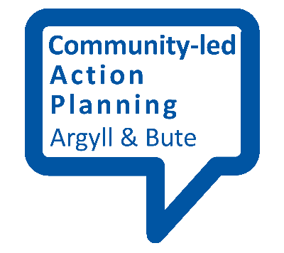
Thinking about your research question

When embarking on the research for your community-led action plan, it is good to have a clear focus for what you want to find out and why so that you are putting your energy and resources towards a clear goal. To aid you in this, it is essential that you have clear and specific research questions.

Start from your community
The exact topics you cover will depend on the social and physical features of your community. Possibilities could include the local environment, community safety, housing, community facilities, facilities for young people, community groups and activities, local services, local assets and sites of interest, the local economy, energy (e.g. wind power schemes) and sport and leisure.

It may be good to get some kind of profile of your community. This could include information such as:
- A stakeholder analysis – who in the community has a contribution to make and who will be affected? This might include individuals, community and voluntary groups, public agencies and local businesses.
- The number of people in the community
- The make-up of the community in terms of age, gender, ethnicity and disability.
- What local facilities and services are available
- Other assets such as land and buildings that the community could make better use of

Take a look at existing plans and strategies by local agencies, as these will also give an indication of local priorities. Argyll and Bute Community Planning Partnership (CPP) has created a question bank based on its Single Outcome Agreement 2013-23 delivery plan, which could help you to align your community-led action plan with the objectives already agreed by all the partners in the CPP.

Leave it open
Avoid setting research questions that presume others will agree.
For instance:
Are there sufficient community facilities to meet the needs and aspirations of our community?
…is better than:
We need a brand new community facility for our area – do you agree?

By putting the question in a more open way it becomes a wider inquiry. So there are now a whole set of sub questions for you to explore such as:
- What facilities do we have at the moment?
- How are these used?
- What’s good and bad about them?
- Could they be improved?
- Is there a demand for activities they can’t accommodate?
- What are the alternatives?
- Do we need something new?
- If so how do we demonstrate that?

Be realistic
Another tip is to keep your question realistic and practical, thinking about the time and resources you have to answer it. Being specific may help. A question such as:
‘What facilities do we need to make this a better place to live?’
…is probably a bit too broad and you may end up with a shopping list of issues that is difficult to address.

Key points
- Review your research question a few times to make sure it’s clear and specific.
- Make sure it’s answerable.
- Check no one else has researched the same issue.
- Clarify the sub questions that need to be explored.
- Make sure it matters to the community.

